TG Series LED
200+200W

TGE-4928A-1322F9-KFR02-01

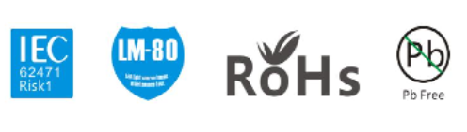

特性 Features
●提供3step出货方案 Available in 3-step EasyWhite® bins
●提供95显色方案 Available in 95 minimum Ra options
●低热阻 Low thermal resistance
●符合ROHS、REACH标准 RoHS and REACh compliant

描述 Description
同一方COB产品具有高光效，高显指，低功耗，发光角度广等一系列特性，这些特性使其成为照明应用的首选.
The TYF COB package has high efficacy, high Ra, low power consumption, wide viewing angle and acompact form factor. These features make the package an ideal LED for lighting applications.

应用 Applications
● 舞台、影视、文旅
Stage, film and television, cultural travel
● 军工、海事
Military, maritime
● 医疗、医美
Medical, medical beauty

目 录
Catalogue

1.产品编码 Product Number 3

2.外形尺寸 Dimensions 3

3.极限参数 Absolute Maximum Ratings 4

4.光电特性 Electrical-Optical Characteristics 5

5.色区参考图 The reference map color area 6

6.典型特性曲线 Typical Characteristic Curves 7

7.可靠性试验 Reliability Test Items And Conditions 9

8.包装 Packaging 10

9. 使用注意事项 Caution 11

- 产品编码 Product Number
1 | 2 | 3 | - | 4 | 5 | 6 | 7 | 8 | - | 9 | 10 | 11 | 12 | 13 | 14 | - | 15 | 16 | 17 | 18 | 19
T | G | E | - | 4 | 2 | 2 | 4 | C | - | 1 | 2 | 1 | 2 | F | 9 | - | K | F | R | 0 | 3

编码序号 Code No | 含义 PKG Information
1-3 | 产品系列 Range of products
4-8 | 产品外形 Designates product type
9-12 | 串并方案 Product specifications Size
13-14 | 亮度等级 Class of brightness
15-19 | 颜色代码 Color code

2、外形尺寸 Dimensions
单位(Units):毫米(mm)

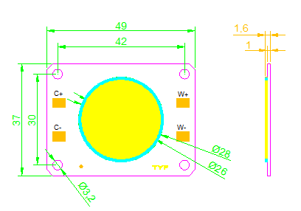

备注/Postscript:
所有尺寸单位为mm ，如无特殊说明误差范围为±0.2mm
All dimensions area in mm tolerance is ±0.2mm unless otherwise noted.

3、极限参数 Absolute Maximum Ratings
项目  Item | 符号  Symbol | Min | Typ | Max | 单位  Unit
极限功率 Limiting power | P | - | 200*2 | 230*2 | W
正向电压  Forward Voltage | VF | 32 | 34 | 36 | V
正向电流  Forward Current | IF | - | 5000*2 | 5500*2 | mA
工作焊点温度  Operating Temperature | TC | -40 | - | 85 | °C
结点温度  Junction Temperature | Tj | - | - | 150 | °C
储存温度  Storage Temperature | Tstg | -40 | - | 105 | °C
静电击穿电压  ESD Sensitivity | ESD | - | - | 2000 | V
反向电压  Reverse Voltage | VR | Reverse testing is not allowed |  |  | /
焊接温度  Soldering Temperature | Tsld | 350ºC/3-5sec. |  |  | ℃/S
热阻  Thermal resistance, junction to solder point | Rthj-s | 0.15 |  |  | ℃/W

补充说明 Additional Remarks

·极限功率和正向电流 是指模块温度通过使用合适的散热体下的最大设置数值；
Max power and positive current mean the maximum setting value of the bottom temperature of led light source by using the appropriate heat sink.
·最初连接错误的反向电压，超出将可能损坏模组；
Connection error and off-limits voltage may damage LED chip.

4、光电特性 Electrical-Optical characteristics （T j = 25ºC）
表1: 在Tj=25℃时测试的光电参数
Product  产品系列 | CRI  显色 | CCT  色温(K) | Luminous Flux  光通量(lm)5000MA | Efficacy  光效(lm/W)5000MA | Voltage 电压（V)  VF5000MA | Part Number产品编码
TGE-4928A-1322F9 | 95 | 2700 | 14500-16500 | 80-90 | 32-36 | TGE-4928A-1322F9-KFR02-01
TGE-4928A-1322F9 | 95 | 6500 | 21000-23000 | 120-130 | 32-36 | TGE-4928A-1322F9-KFR02-01

说明：
表1备注Table 1 note：
·测试环境温度25 ℃,若使用不同电流或不同的环境温度测试，会引起色温及电压的变化；
Testing environment temperature25 ℃,and CCT and voltag e will changed if tested in different current and environment temperature.
·不同标准测试仪正常测试允许公差：电压±0.1V , 流明±5% ,显指±2,色坐标±0.005；
Tolerance among different testing machine: Voltage:±0.1V, Lumen±5%, CRI±2, Color coordinate ±0.005.

5、色区参考图 The reference map color area
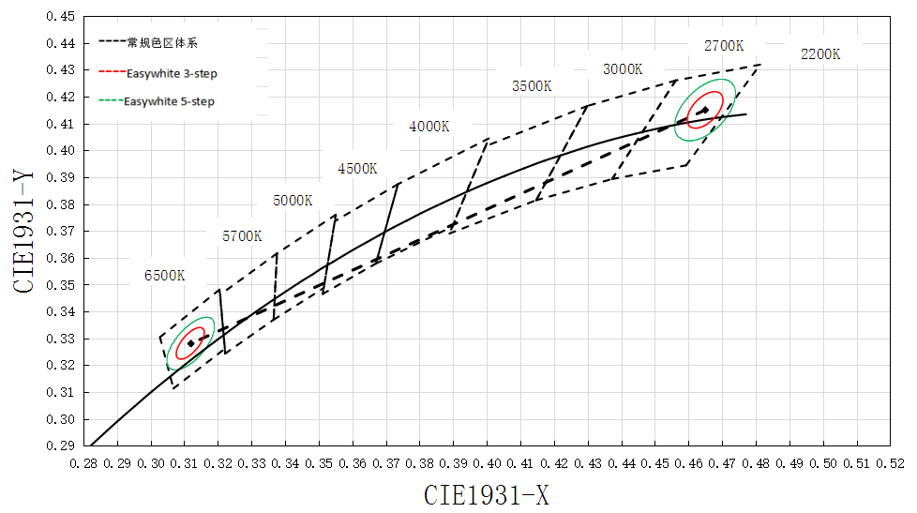

CIE(X,Y)坐标 CIE coordinates (X, Y)
Nominal  CCT | Center Point |  | MAJOR AXIS (a , b) |  |  | Ellipse Rotation Angel,θ
Nominal  CCT | X | Y | 2-Step | 3-Step | 5-Step | Ellipse Rotation Angel,θ
2700K | 0.4592 | 0.4052 | (0.0054, 0.0028) | (0.0081, 0.0042) | (0.0135, 0.007) | 53.70
6500K | 0.313 | 0.3184 | (0.00548, 0.00236) | (0.00822, 0.00354) | (0.0137, 0.0059) | 58.57

备注/Postscript:
色域范围为同一方自定义色区，色域范围可控制在自定义色区所规范的SDCM≤3。The color gamut range is the TYF custom color zone, which can be controlled in the SDCM 3 specified by the custom color area.

6、典型特性曲线/Typical Characteristic Curves
（1）.典型光谱分布

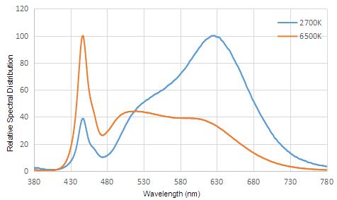
Typical spectral distribution

Figure 1a. Typical normalized power vs. wavelength for at test current,RA95 Tj =25°C.
Light Output Characteristics
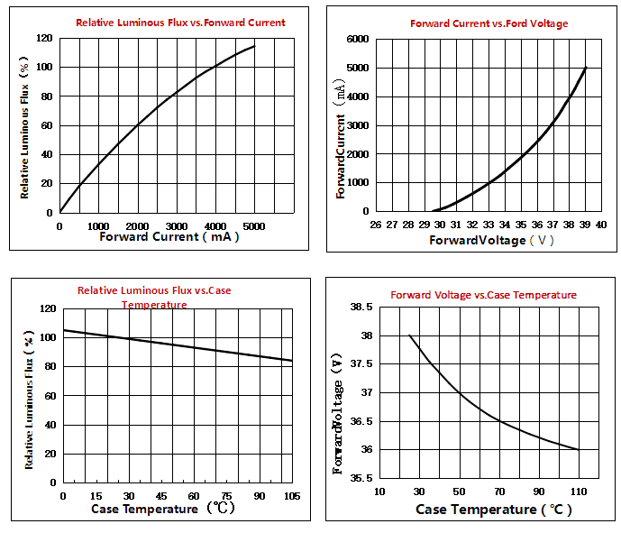

Radiation Pattern Characteristics
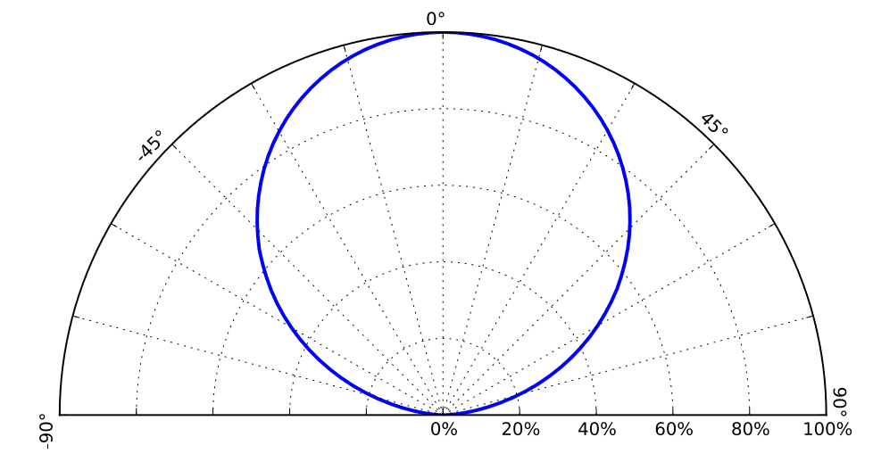
Typical radiation pattern for T at test current, Tj =25°C.

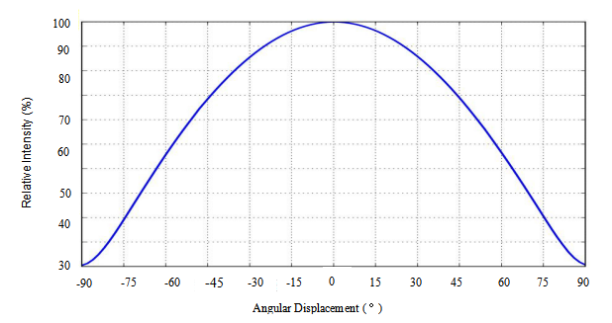

Typical polar radiation pattern forat test current, Tj =25°C.
7、可靠性试验/Reliability Test Items And Conditions
测试项目和测试条件 Testing items and testing conditions
序号 No. | 试验项目  Test Item | 参考标准 reference standard | 试验条件  Test condition |  | 样品数量 Sample Quantity | 失效数量 Failure Quantity
1 | 高低温冲击 Thermal shock | JESD22-A104E | (-40℃15min)-----+120℃(15min), ↑↓10 mins,200cycles |  | 22pcs | 0
2 | 高温存放HighTemperature  Storage | JESD22-A103D | +100℃，1000h |  | 22pcs | 0
3 | 低温存放  Low Temperature  Storage | JESD22-A119 | -40℃，1000h |  | 22pcs | 0
4 | 高温高湿老化High Temperature,High Humidity,Aging Test | JESD22-A101C | T=+85℃,RH=85% | IF=4000MA  1000h | 22pcs | 0
5 | 高温使用寿命  High-temperature operation | IES LM80-2015 | T=+105℃, | IF=4000MA  1000h | 22pcs | 0
6 | 低温使用寿命  Low temperature operation | JESD22-A108D | T=-40℃, | IF=4000MA  1000h | 22pcs | 0
7 | 回流焊湿度敏感实验Moisture/Reflow Sensitivity Test | J-STD-020E | Precondition: 60℃.60%RH.168H Tsld=260℃.10sec. 3 Reflows |  | 22pcs | 0

失效判定标准 Criteria For Judging Damage
项目  Test Items | 测试条件  Test Condition | 判定标准  Criteria For Judgement
项目  Test Items | 测试条件  Test Condition | Min. 最小 | Max. 最大
正向电压  Forward Voltage | IF=4000MA | / | U.S.L*1.1
反向电流  Reverse Current | VR=5V | / | U.S.L*2.0
光通量  Luminous Flux | IF=4000MA | L.S.L*0.7 | /
8、包装/Packaging
静电袋标签 Electrostatic bag label
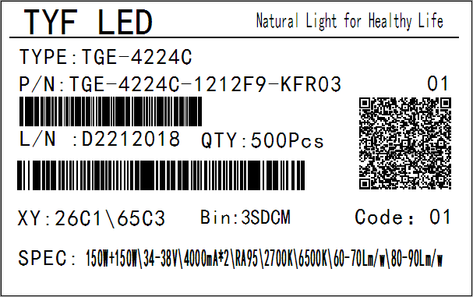

背面镭射图示/Laser image on the back

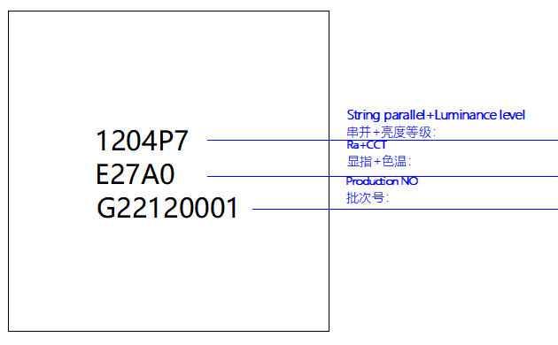

托盘包装图/Tray packing drawing
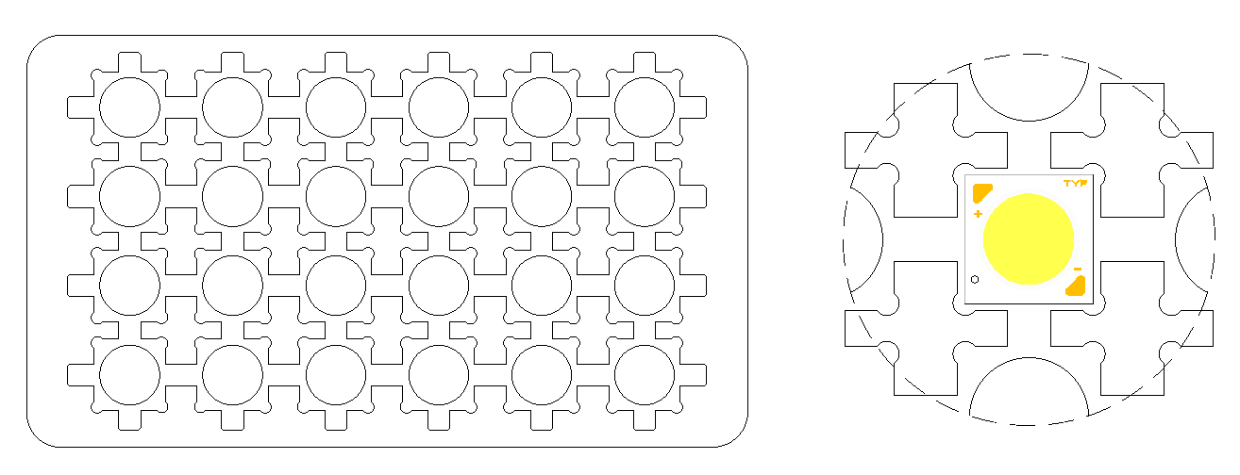

备注 Postscript:
·每个吸塑盘可以包装1~8 pcs COB/Each blister disk can pack 1 to 8 pcs COB
·每个吸塑盘上面会贴一张标签/A label will be attached to each blister disk
·吸塑盘最终会静电袋真空包装/Blister disk will be vacuum packed with electrostatic bag finally

9、使用注意事项 Caution
1.推荐的焊接条件 Recommended welding conditions

对于手工焊接。请使用无铅焊接，焊接应该通过焊接钻头被植入且温度低于350℃，并在3.5s之内被完成。在进行焊接时，不应对树脂部件施加外力。下一次焊接工艺应在产品恢复到环境温度后进行.
For manual soldering. Please use lead-free soldering and the soldering shall be implemented using a soldering bit at a temperature lower than 350C, and shall be finished within 3.6 seconds for one land. No external force shall be applied to resin part while soldering is implemented. Next process of soldering should be carried out after the product has return to ambient temperature.

2.化学接触危害 Attention

接触一些常规使用到光源制造和集合装配上的化学物质能引起LED系列的损坏，请参阅同一方安装说明以获得更多信息.
Exposure to some chemicals commonly used in luminaire manufacturing and assembly can cause damage to the LED array. Please consult TYF Installation Instruction for additional information.

3.静电防护 Electrostatic protection

LED属于I级静电敏感器件，接触、使用过程做好防静电保护；
LED belong to grade I electrostatic sensitive device, please do ESD protection when touch and use

4.接触发光面风险 Risk of contact with light-emitting surfaces
避免与LES接触。不要触摸LED系列的LES或在LES上(黄色荧光粉树脂区域)施加压力。接触可能对LED系列造成损坏。光学和反射器不得安装在与LES(黄色荧光粉树脂区)接触的地方。光学器件可安装在 LED系列的塑料外壳的上表面。使用LED系列外壳、边缘和/或安装孔的机械特性来根据需要进行定位和保护光学器件
Avoid any contact with the LES. Do not touch the LES of the LED array or apply stress to the LES (yellow phosphor resin area). Contact may cause damage to the LED array. Optics and reflectors must not be mounted in contact with the LES (yellow phosphor resin area). Optical devices may be mounted on the top surface of the plastic housing of the TYF LED array. Use the mechanical features of the LED array housing, edges and/or mounting holes to locate and secure optical devices as needed

5.储存条件 Risk of contact with light-emitting surfaces
LED必须存放在清洁的环境中。密封袋的保质期为12个月，温度为0~40ºC，相对湿度为0~90%
撕开包装剩余的LED需重新密封包装，放置在干燥的环境

LEDs must be stored in a clean environment. Shelf life of sealed bags is 12 months at temperature 0~40 ºC, 0~90 % RH.
Repack unused products with anti-moisture packing, fold to close any opening and then store in a dry place

